Same day baggage delivery service

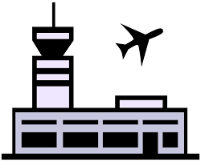
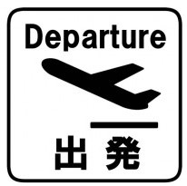
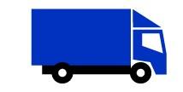
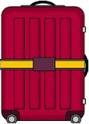

Impossible to receive | Possible to receive

5:00 PM ～
～ 11:00 AM
3:00 PM ～

Reception desk deadline time Received possible time Departure time

Selection of delivery box and suitcase

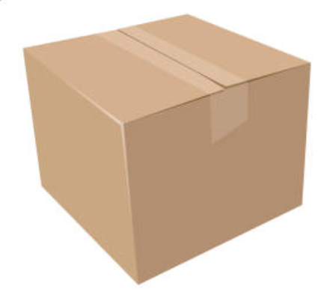
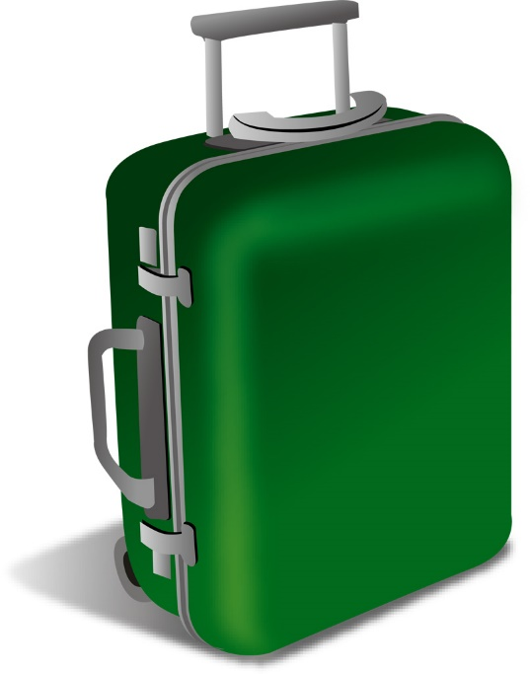
\ 2,500 per box

- Total of 3 sides dimensions: 158cm or less
- Up to 25kg per box

We cannot handle luggage to which the following condition apply.
●Cash, valuables, etc.
●The total value of packed luggage is 300,000JP yen or more.
●The luggage any items specified as hazardous by International Air Transport Association (IATA).
●Frozen food, chilled food, breakable items, fragile items, living animals, perishable food, etc.

